|  |  |
| --- | --- |
| **Assignment Case** |  |
| COMP6153 | T0316  Operating System |
| **Computer Science** | **O203-COMP6153-CN07-01** |
| ***Valid on*** *Even Semester Year 2019/2020* | **Revision 00** |

1. Mahasiswa tidak diperkenankan untuk:

*Student(s) is not allowed to:*

* + 1. Menyontek hasil karya mahasiswa lain sebagian maupun seluruh proyek/kuis

*Cheat other students’ project/quiz, in part or the whole*

* + 1. Menyadur karya orang lain, baik sebagian maupun seluruh proyek/kuis

*Copy from other’s work, in part or the whole*

* + 1. Mengunduh dari internet sebagian maupun seluruh proyek/kuis

*Download from the Internet, in part or the whole project/quiz*

* + 1. Mengerjakan soal dengan tema yang tidak sesuai dengan tema yang ada di soal proyek/kuis

*Use different theme than the existing one for doing the project/quiz*

* + 1. Melakukan tindakan kecurangan lainnya

*Conduct other fraudulent actions*

* + 1. Secara sengaja maupun tidak sengaja melakukan segala tindakan kelalaian yang menyebabkan hasil karyanya berhasil dicontek oleh mahasiswa lain

*Accidentally or intentionally conduct any action that could cause the results of the project/quiz was taken by other student(s)*

1. Segala kecurangan yang dilakukan mahasiswa seperti yang dicantumkan pada butir 1 akan dikenakan sanksi sesuai dengan peraturan yang berlaku (Tata Tertib Pembentukan Kelompok Proyek & Kuis, Pengumpulan Proyek, Pelaksanaan Kuis Praktikum Software Laboratory Center). Peraturan tersebut dapat diunduh dari Binusmaya.

*Any fraud performed by student(s) as specified in point 1 will be penalized in accordance with applicable regulations* (Tata Tertib Pembentukan Kelompok Proyek & Kuis, Pengumpulan Proyek, Pelaksanaan Kuis Praktikum Software Laboratory Center). *Those regulations can be downloaded from Binusmaya.*

1. Untuk proyek, kriteria penilaian dapat ditanyakan pada asisten Anda.

*For the project, the assessment criteria can be asked to your teaching assistant.*

## Soal

*Case*

1. From **home directory**, write a **command line** to create the directory based on the hierarchy below in a single execution!

<Home directory>

`-- Shop

|-- Contacts

| |-- Suppliers

| |-- Manufacturers

| |-- Customers

|-- Products

|-- HDD

|-- SSD

* Jawaban Versi 1:

mkdir -p Shop/{Contacts/{Suppliers,Manufactors,Customers},Products/{HDD,SSD}}

* Jawaban Versi 2:’

mkdir -p Shop/Contacts/Suppliers Shop/Contacts/Manufacturers Shop/Contacts/Customers Shop/Products/HDD Shop/Products/SSD

1. From **Shop folder**, write a command line to create a new file named **Suppliers.txt** inside the **Suppliers** folder, then **set permission** so **owner** able to **read**, **write** and **execute** the file, **groups** to be able to **read** and **execute** the file, while **others are** only able to **read** the file.

* touch Contacts/Suppliers/Suppliers.txt;chmod 754 Contacts/Suppliers/Suppliers.txt

1. From **Shop folder,** write a command line to **search files** with the following criteria:

* **Inside Contacts folder**
* **The types are .txt**
* find Contacts -name *.txt

1. Write a command line to display **all processes for all users**, while **sorting the processes by process name in ascending** order.

* top -o -pid

1. Java Programming:

**CoNputer Storages**

**CoNputer Storages** is a newly established computer storage manufacturer in Indonesia. As a programmer, you are asked to create a program to handle customer orders.

Here are the detail requirements of the application:

* The application uses **Object Oriented Programming** concept and **inheritance**.
* Create methods to calculate the **base price**, **multiplier,** and **price**.
* When the **program starts**, ask the user to **input the menu** **they want to** **order**. Validate the inputted menu must be between “**HDD**” and “**SSD**”(**case sensitive**).

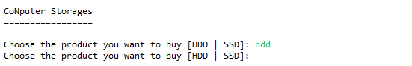

**Figure 1. Choose Product**

* If user input **HDD** on the menu, then:
* Ask the user to input the **brand**. Validate the **brand** must be “**Samsong**”, “**Sandesk**”, “**Toshibo**” or “**Kingstan**” (**case sensitive**).
* Ask the user to input the **label**. Validate the **label** must be **between 5 to 15 characters**.
* Ask the user to input **capacity**. Validate the **capacity** must be **between 128 and 256**.
* Ask the user to input **quantity**. Validate the **quantity** **must be between 1 to 20**.

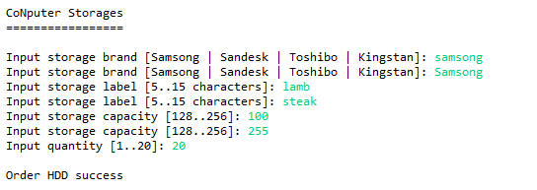

**Figure 2. HDD Input**

* Determine the **base price** based on the following rules:

|  |  |
| --- | --- |
| **Brand** | **Base Price** |
| Samsong | 1000 |
| Sandesk | 2000 |
| Toshibo | 3000 |
| Kingstan | 4000 |

* Calculate the **price** with the following formula:

**Price** = base price * capacity * quantity

* Display **label**, **brand**, **capacity**, **quantity,** and **price** of the inputted order.

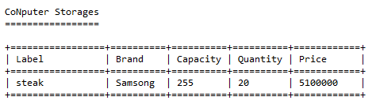

**Figure 3. HDD Detail**

* If user input **SSD** on the menu, then:
* Ask the user to input the **brand**. Validate the **brand** must be “**Samsong**”, “**Sandesk**”, “**Toshibo**” or “**Kingstan**” (**case** **sensitive**).
* Ask the user to input the **label**. Validate the **label** must be **between** **5 to 15 characters**.
* Ask the user to input **capacity**. Validate the **capacity** must be **between 128 and 256**.
* Ask the user to input **quantity**. Validate the **quantity** **must be between 1 to 20**.
* Ask the user to input the **connection**. Validate the **connection that** must be either “**PCIe**” or “**SATA**”(**case sensitive**).

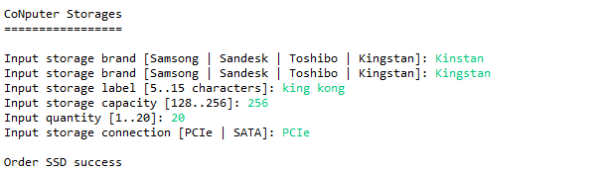

**Figure 4. Input SSD**

* Determine the **base price** based on the following rules:

|  |  |
| --- | --- |
| **Brand** | **Base Price** |
| Samsong | 1000 |
| Sandesk | 2000 |
| Toshibo | 3000 |
| Kingstan | 4000 |

* Determine the **multiplier** based on the following rules:

|  |  |
| --- | --- |
| **Connector** | **Multiplier** |
| PCIe | 2 |
| SATA | 3 |

* Then, calculate the **price** with the following formula:

**Price** = base price * capacity * quantity * multiplier

* Display **label**, **brand**, **capacity**, **quantity**, **connection,** and **price** of the inputted order.

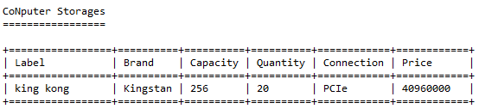

**Figure 5. SSD Detail**